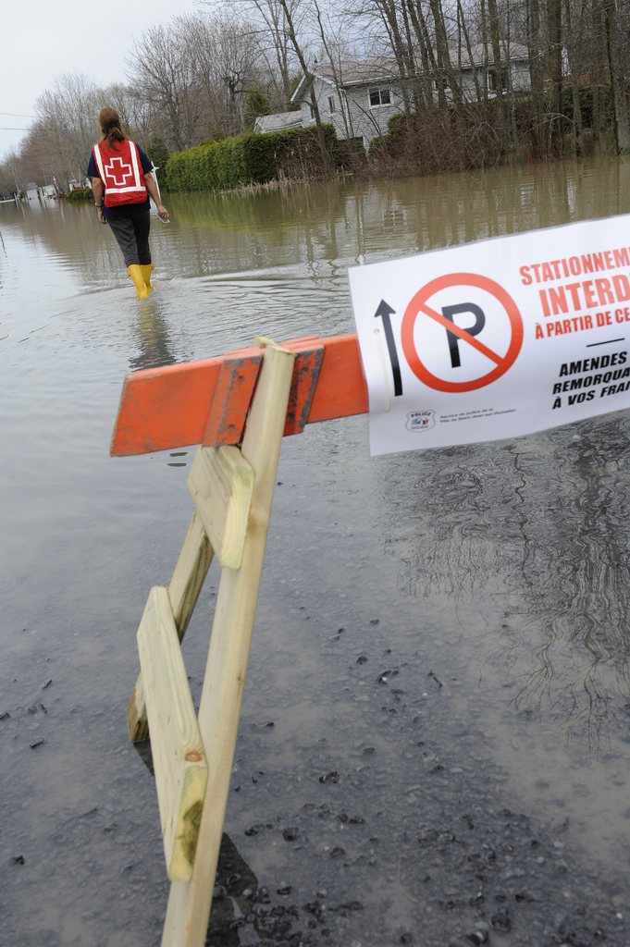C:\Users\bjudek\AppData\Local\Microsoft\Windows\Temporary Internet Files\Content.Word\L_Can_Red_Cross_CMYK_En.eps

**PERSONAL SAFETY AND SECURITY GUIDANCE in domestic Response Operations**

**Notice**

This personal security resource has been developed to provide guidance to support the safety and security of Canadian Red Cross (CRC) personnel including volunteers, staff and others) working Canada. It is your individual responsibility to read it carefully and to understand its content.

No handbook will provide guidelines for every situation and this document should not be considered as the sole source of information. CRC personnel should be informed of emergency plans, as well as safety and security procedures developed for each CRC office, branch, warehouse, shelter or other work sites. Emergency plans and safety and security procedures must be communicated during orientations, and accessible through your immediate supervisor.

Living in Canada, we are fortunate to have effective security provision through police, military and private security providers. However, individuals must always practice continuous situational and self-awareness by using their own training, CRC policies and good judgement to determine what course of action is best suited for their specific situation and the objectives they are seeking.

Please forward any concerns, feedback or suggestions during your individual or team debriefing process, or if necessary, immediately to the Site Manager or immediate supervisor.

Table of Contents

[Introduction 1](#_Toc442884867)

[Security Responsibility 2](#_Toc442884868)

[Conduct and Personal Behaviour 4](#_Toc442884869)

[The Seven Pillars of Security 5](#_Toc442884870)

[Image and Acceptance: Communicating our Principles 7](#_Toc442884871)

[Interpersonal Communication 8](#_Toc442884872)

[Cultural and Gender Considerations 10](#_Toc442884873)

[Personal Safety and Security – Key Points 11](#_Toc442884874)

[Main Security Threats: Prevention and Response 12](#_Toc442884875)

[Civil Unrest 13](#_Toc442884876)

[Crime/Robbery 13](#_Toc442884877)

[Health Hazards 14](#_Toc442884878)

[Natural Disasters 14](#_Toc442884879)

[Fire 16](#_Toc442884880)

[Sexual and Gender Based Violence (SGBV) 17](#_Toc442884881)

[Incidental Exposure to Acts of Violence (collateral damage) 19](#_Toc442884882)

[Other Considerations 22](#_Toc442884883)

[Work Locations/Sites 22](#_Toc442884884)

[Information and Advisories 22](#_Toc442884885)

[Social Media, Information Management / Information Security 22](#_Toc442884886)

[Stress and Resilience 24](#_Toc442884887)

[Handling Cash, Gift Cards and Cash Cards. 27](#_Toc442884888)

[Incidents and Other Emergencies 28](#_Toc442884889)

[Checklists 29](#_Toc442884890)

[Emergency Contacts 31](#_Toc442884891)

[Other Resources 32](#_Toc442884892)

[Notes 33](#_Toc442884893)

# Introduction

**Goal**

This booklet is a personal awareness and risk reduction tool, which aims to enhance the security and well-being of National Society personnel at the Canadian Red Cross and the vulnerable people we assist.

**Objective**

The purpose of this booklet is to establish easy-to-understand security procedures to help prevent security incidents before, during and after the provision of services to clients.

**Target Audience**

This booklet is intended for CRC Personnel, Management and Leadership.

***Security is a state of mind of alertness and readiness.***

**Safety**

The condition of being safe from undergoing harm or causing hurt, injury, or loss; being protected against physical, social, spiritual, financial, political, emotional, occupational, psychological, educational or other types or consequences of failure, damage, error, accidents, harm or any other event which could be considered non-desirable.

**Security**

The quality or state of being secure and free from danger; measures taken to guard against any form of physical, emotional or psychological harm such as sabotage, crime, and attacks.

# Security Responsibility

A critical component of safety and security management is clear accountability. **Accountability exists with the individual, the team, management and the CRC as a whole.**

**Individual – Volunteer, Staff and Delegates. (Personnel)**

All CRC Personnel accept and understand the organization’s philosophy, values, mission and mandate. This includes adherence to our Fundamental Principles, Code of Conduct and safety and security procedures. Each person is responsible for their individual personal conduct and professionalism. This includes practicing constant situational and self-awareness. The consequences of your actions affect not only you, but your team and the organization as a whole. All CRC personnel must equally feel empowered to request security guidance and briefings and report any breaches of compliance or gaps in the management of theirs and their team member’s security. Each individual on assignment should feel empowered to ensure that the responsible CRC Site Manager has developed and communicated minimum security guidelines that include preventive procedures, contingency planning, emergency evacuations, travel procedures, etc.

**Security is everyone’s responsibility**

Security management is not an imposition of rules and regulations, but rather a system for developing guidelines for staff so that the CRC may continue to deliver life saving assistance to those who need it.

**Team -** Your team is an important dimension of safety and security. If your team does not function well, it will respond poorly to security emergencies. A healthy and productive team takes care of its members by ensuring good communication and cooperation.

**Management -** Line/Site management and Team Leaders are also accountable for the safety and security of their personnel. They must ensure that personnel are informed of safety and security risks and the measures implemented to reduce risks. They must also recognise the right of refusal that personnel are allowed to practice should they feel that the security risks of their assignment surpasses their individual threshold of acceptable risk.

**Organizational -** CRC, alongside other movement partners (ICRC, IFRC and other National Societies) have invested in and will continue to promote a culture of safety and security. This requires the inclusion and ownership of security by all levels of Management and Personnel.

**Protection Team -** The Protection Team is comprised of the Site Manager, the Safety and Well-Being Manager and the People Services Supervisor. Their role is to provide guidance and to monitor a CRC shelter against recognized standards of care and protection. The team also determines the required course of action that can be taken if a concern related to safety, protection or welfare has been made. Safety, protection and welfare concerns are not always black and white. It is recognized that sometimes people are unsure as to their obligations to report. The protection team is there to provide support to ensure that the CRC takes appropriate action in compliance with the law.

**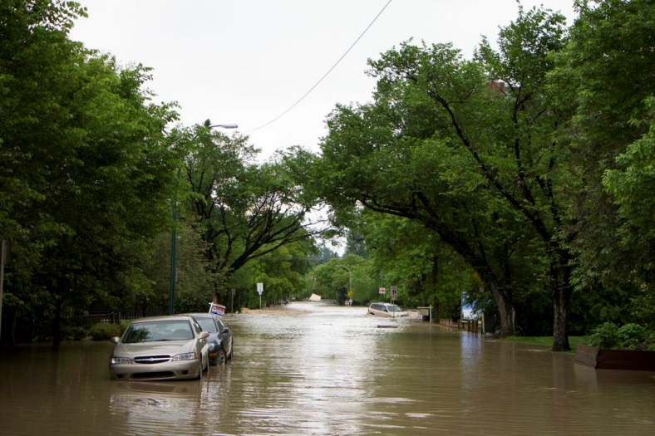**

*Due to the nature of our work and of the security environments in which we work, there will always be residual risk.*

# Conduct and Personal Behaviour

All CRC personnel must be aware that their personal behaviour and actions can have a direct effect on their own security, the security of other Personnel and the image of the Red Cross and Red Crescent Movement. All CRC personnel must:

1. Sign and observe the CRC Code of Conduct and act in a manner that does not jeopardize their personal safety and security or that of others;
2. Respect and uphold the Fundamental Principles of the Red Cross Red Crescent Movement at all times; and,
3. Follow the appropriate reporting process for any actions or inappropriate behaviour that either breaches the Code of Conduct/Fundamental Principles or jeopardizes staff, volunteers, security etc.

Individuals should always consider how their personal behaviour and actions might be perceived and avoid any behaviour or attitudes that may offend or provoke aggression. Inappropriate behaviour and conduct can seriously jeopardize the safety and welfare of all personnel.

# The Seven Pillars of Security

Our security is underpinned by seven principles, called the seven pillars of security.

**Acceptance** – highlights the need to be accepted as a neutral, impartial and independent humanitarian actor by all parties. We work in locations where the culture and working environment may be different to our own, and we need to be aware of culture, values and customs and learn to work in a manner that is respectful without compromising our values, codes of conduct and dignity. We accept the possibility of working in an insecure environment and we accept the need to work in a manner consistent with the Fundamental Principles, the Code of Conduct and security procedures.

**Identification** – CRC identifies itself clearly by the use of the Red Cross emblem but also by its operational profile. We identify ourselves by wearing our CRC badge, carrying CRC identification and wearing the CRC Disaster Management vests. Sometimes, our vehicles, offices and work places are clearly signed with the emblem.

**Information** – mechanisms should be in place to ensure that up to date security related information is passed to those that need it. A culture of sharing information should be developed. We should all make an effort to inform ourselves about safety and security in our work area and collect and share information with team members and report security incidents. Information related to military, political or religious matters should not be reported by radio or discussed in public.

**Policies and Procedures and or Regulations**– are established to mitigate identified risks. They contribute to the safety and security of our staff, and of our equipment and supplies; and thereby contribute to the success of our programs. Policies and procedures are mandatory and must be understood by all CRC personnel. Deliberate breaches of policies can have severe consequences for the safety and security of personnel and equipment and, as such, are usually considered as serious misconduct and may lead to remedial actions.

**Behaviour** – individual behaviour is a key determinant of security – for ourselves as well as for our team members. We should never allow ourselves to be provoked into offensive or culturally insensitive personal behaviour. Correct, polite, impartial and neutral behaviour is expected. We need to behave honestly and demonstrate self-discipline and respect for the local culture, noting that our behaviour can indirectly affect the security of our colleagues. We need to remember that we are representing the Movement 24/7 and our behaviour should reflect this. By keeping a low personal profile we reduce the risk of becoming vulnerable to crime or involved in a security incident. We should maintain our physical and psychological well being, and ask for assistance if we need it. We should be willing to report security related incidents (or behaviour) to management.

**Communication** – reliable and independent communications systems allow personnel movement to be monitored, urgent security-related messages to be passed and assistance to be arranged. We need to observe security procedures related to communication and reporting, understand how to maintain and use our communication equipment and comply with these procedures, especially by speaking clearly and slowly in emergency situations.

**Protection** – a variety of security measures contribute to the protection of staff and equipment, including taking care with the selection and/or set up of work locations/sites, facilities, and instituting communications procedures. Fire, incident and emergency procedures are established and should be known and observed by all staff. We should familiarize ourselves with emergency procedures and be prepared to react in accordance with emergency plans.

# Image and Acceptance: Communicating our Principles

It is very important when communicating our principles to others outside the CRC that we adjust our language to ensure clarity and understanding about our purpose and guiding principles.

Our implicit and explicit messages can directly affect CRC image and acceptance which also correlates to security and reputational risks.

The purpose of referring to our principles is centered on gaining humanitarian access for the provision of assistance to those in need and in the provision and promotion of protection. Safeguarding our physical and psychological safety and security is another important dimension as we aim to be understood and accepted and thus not the target of intentional harm. Cultivating acceptance is critical to how we conduct our work and attain programmatic objectives while staying safer and more secure. We can attain this through the use of thoughtful and SIMPLE language.

**A few dos and don’ts:**

* Be clear about the specific purpose and objectives of your assignment while maintaining honesty and openness.
* Try to avoid using CRC specific acronyms or technical terms and concepts.
* Be sincere; speak with compassion, sincerity and transparency.
* Be clear that we are not a government agency and that as such we have a measure of independence on when/how we deliver our services. (Independent, Neutral, Impartial and Humanity)
* In case the situation escalates into hostility, please refer to the next section on techniques for diffusing anger and aggression.
* Be respectful – if there are differences in perspective and or culture never lose your dignity, stay on message and be clear on the issues – listen.
* You can agree to disagree. Know how to disengage respectfully and/or provide another CRC point of contact for more information or by accessing CRC established complaints mechanisms.

# Interpersonal Communication

This section is meant as an aide-memoire to assist CRC volunteers and staff when interfacing with affected population or other angry individuals in the course of the emergency response. It does not replace adequate training and practice for learning interpersonal skills to help defuse anger and aggression.

***How we communicate is vital to our personal security.***

**Constructive Engagement**

Can positively influence the outcome of an incident, or prevent a situation becoming an incident.

**Interpersonal Communication (Key Points)**

* Can be both *Verbal and Nonverbal* (if language is a barrier non-verbal may be the only means of communication.)
* We need to be aware of what signals we are giving through our body language.
* Communication technique needs to be appropriate to local and cultural norms and to each specific situation.
* Any insecure environment will undoubtedly be stressful. Being stressed may in turn affect the way we communicate and further compromise our security (and that of others).
* Interpersonal conflicts (disagreements or arguments) are particularly stressful whether in an insecure environment or not.
* It is essential to remain calm and capable of employing the most appropriate communication techniques for the situation - this takes practice and training.
* Be aware of your own conflict management style and how you react under stress.
* Remember the context you are in and how the perception and expectations of others can be different from what you may be used to (gender, age, ethnicity, etc...)

**Key Points: Defusing Anger & Hostility**

1. Anger & Aggression are related to frustration and feelings of powerlessness
2. There is a close physiological connection between fear and anger. Be aware of others and of your own reactions.
3. Know your own anger triggers and have a plan for dealing with triggers in a safe way.
4. Hostility from someone’s anger can provoke an angry response from you (and exacerbate the situation)
5. Be aware of, and learn skills in, defusing anger /hostility

*Remember you are wearing the “red vest” that gives a power imbalance. Never misuse your power that results in harm.*

**A few techniques for defusing Anger**

* **Listen -** without interrupting. Paraphrase / reframe to show you are listening (but say little).
* **Show interest** – to concerns. Ask for clarification with open ended non-threatening questions (but don’t contradict / correct an angry person before they have finished venting their frustration.)
* **Body Language** – be aware of gestures/ expressions. Stand at an angle rather than face to face.
* **Empathise** - do not be judgemental. Recognise prejudices and try to understand the situation.
* **Focus on the issue** – not the person. Gradually try to shift dialog from personal confrontation to an issue that can have a mutually acceptable solution.
* **Maintain dignity** - for yourself but allow aggressor to save face.
* **Do not show contempt** - for an angry individual (even if you feel it).
* Use **Situational Judgement** - whether to try to defuse anger / hostility and attempt negotiation or to comply without delay.

***If faced with an angry and armed aggressor co-operate fully with their demands unless totally unacceptable (e.g. if compliance results in harm to self or others) and call for help immediately.***

# Cultural and Gender Considerations

CRC recognizes that individuals may face different risks or be more vulnerable to certain threats because of their religion, ethnicity, sex, gender and or sexual orientation. In some circumstances, however, the prevailing security context or specific risks to an individual or response may require CRC to adapt relevant safety and security procedures to best reduce individual and team vulnerabilities.

All CRCS personnel are asked to practice important levels of self awareness and strive to reduce their vulnerability to safety and security risks with appropriate behaviour and judgement.

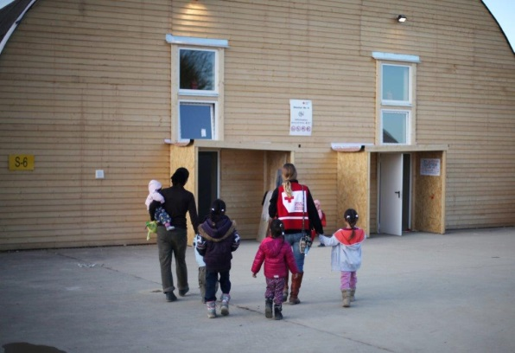Few organizations are as culturally diverse as the Red Cross and Red Crescent Movement. Our work, colleagues and the persons impacted and/or displaced by disaster with whom we will work, may be from different cultures and socio-economic situations than our own. Culture is our “social coding” – and it consciously and sub-consciously has a direct affect on our attitudes, values and behaviour. Sometimes we forget that others are “different” and will have different attitudes, values and behaviour than ourselves. No matter how much we work with people from other cultures, religion and gender identities, we must remain aware that communication difficulties and relationship problems can arise from insensitivity, disrespect or ignorance. We should understand our own culture while being adaptable and showing empathy for others. We need to be flexible, tolerant and non-judgmental, and not let minor cultural differences upset us unless they breach our code of conduct and principles, in which case, they must be reported.

# **Personal Safety and Security – Key Points**[[1]](#footnote-1)

|  |  |
| --- | --- |
| **Awareness** | Maintain awareness of self, team, the environment and cultural norms. Be sensitive to situation/culture, do your own self-assessment (position yourself in the situation). |
| **Vigilance** | Be suspicious of what is unusual, risky or threatening. Notice when things are not normal. Protect personal information, documents and valuables. |
| **Avoidance** | Avoid confrontations and situations that could turn threatening. |
| **Do not become conspicuous and predictable** | Do not draw attention to yourself through behaviour, manner or dress. Wherever possible avoid routines to make it difficult for someone to predict your movements, especially when managing gift or cash cards. |
| **Common sense and initiative** | A large part of good security practice is based on common sense and sound judgement. A firmness of direction based on sound judgement, when danger is sensed, can forestall further escalation. Be prepared for contingencies; know what to do. |
| **Communication** | Communicating whereabouts, circumstances and plans to colleagues is essential. Concerns, suspicions and observations communicated to other team members help in confirming real problems or eliminating unfounded fears. Be reachable; let someone know where you are. Report security issues/concerns to management. |
| **Personal wellness** | Observe physical and psychosocial wellness protocols, eat well and treat illness and injuries promptly. Ensure adequate rest and relaxation for all team members. |
| **Responsibility for self, team and project** | If one person takes a risk they can put at risk the whole team and project. There is no such thing as a personal risk. |

# Main Security Threats: Prevention and Response

There are various risk reduction measures you can adopt to mitigate your overall exposure to security risk. Some of the main security threats relevant to a domestic context are captured below. These headings are not exhaustive and specific preventive measures should be informed by each situation-specific profile of threat.

***Always WEAR your SEATBELT...and remember the use of communication devices is prohibited while driving.***

**Transportation Accidents (road)** Road traffic accidents account for the most common type of safety incident and MUST be reported. Drivers must have a satisfactory Motor Vehicle Record (MVR) approved and a valid driver’s license (see HR Policy 3.7 – Use of Vehicles). As a driver or passenger of a CRC vehicle, always ensure you have obtained authorization for use of the vehicle; that you have completed the vehicle checklist before departure from any point; that documentation such as insurance and vehicle registration are accessible; repair, safety and first aid equipment are fully stocked inside the vehicle; weather and road conditions are verified and that driving be adjusted to these conditions; and, that regular communications with supervisor/team leader are considered in your travel planning.

If you are involved in a road traffic accident:

* Know and understand CRC procedures and protocols beforehand;
* Report immediately to supervisor, and to police;
* Assist injured people if possible;
* Do not become involved in any settlement at the scene; and,
* Record details - location, date, time, conditions, contacts, and witnesses
* Report the accident to appropriate authorities and CRC contact for specific procedures related to rented vehicles or for CRC-owned vehicles.

## Civil Unrest

Violent instances of civil unrest occur frequently in many countries. Unrest can happen for a variety of reasons; most incidents are related to labor disputes, social or political issues.

Civil unrest can range from small, unorganized rallies to large-scale demonstrations and rioting. Demonstrations can easily evolve into civil disorder with little to no warning; a seemingly orderly crowd can become unruly or violent when stimulated by agitators or security forces. However, it is rare for CRC personnel to be directly targeted during incidents of unrest. Nevertheless, the risk of being inadvertently affected by violence cannot be ruled out.

CRC personnel should remain alert to the possibility of civil unrest in their work location.Fortunately, while you may not always be able to avoid protesters or riots; there are steps you can take to protect yourself from harm. Please consider the following:

* Be prepared. If you know an area is vulnerable for a riot but you can't avoid traveling there:
* Wear clothes that minimize the amount of exposed skin should chemical riot control agents be possibly used.
* Think about your possible escape routes and safe havens
* Carry your identification with you at all times
* Remain calm
* Get inside and stay inside
* Stay on the side-lines
* Avoid being exposed to riot control agents (chemicals)
* Move away from the riot (slowly to avoid drawing attention to yourself); go with the flow until you make your way from the middle to the outside. This requires patience in order to work properly and until you can escape into a doorway or up a side street or alley.
* Do not approach police lines to attempt to cross to safety.

## Crime/Robbery

A cooperative, respectful demeanor during confrontation may avoid further provoking and in some cases, even defuse hostility. Armed assailants are most likely to shoot when they feel their own safety is threatened. When faced with robbery, threats or confrontation, consider the following:

* Do not try to intimidate or be aggressive. Instead, maintain a polite, open, and confident demeanour and try not to show anger or fear.
* Speak quietly and distinctly.
* Keep hands visible and move slowly with precise gestures.
* Respond to requests, but do not offer more than what is requested.
* Never take physical risks in defence of property or money.
* If in a group, do not talk among yourselves more than is necessary

*Primacy of life over assets. No material possessions are worth risking your life. When faced with a demand for property, DO NOT RESIST.*

## Health Hazards

All volunteers and personnel are encouraged to continuously practice self care before, during and after their work. This means knowing your limits, getting enough rest and relaxation, avoiding substance abuse, eating well and drinking enough water. Please also familiarize yourself with local medical outlets, contact information and relevant medical emergency procedures.

It is your own responsibility to ensure you are healthy - physically and mentally - to meet the rigors of your work.

When working in environments or with populations that may have additional health risks such as communicable diseases like tuberculosis, etc., you are responsible for monitoring your health after a response and for seeking medical attention should you feel unwell. Always inform your medical practitioner of possible past exposure.

## Natural Disasters

Natural Disasters of any kind have the propensity to cause significant damage and destruction and can endanger lives. In some countries, seasonal re-occurrences make it easier to plan for natural disasters. Others occur with very little (or no) warning. Consider the following general advice:

*Before a disaster...*

* Keep yourself updated. If possible, listen to radio or any local media for latest developments and news on environmental hazards.
* Know the location of the nearest hospital/medical centre and familiarize yourself with the area.
* Be aware of building or location emergency exits, protocols and assembly points.
* Agree on regrouping in a safe area and ensure that everyone is accounted for as is outlined in the site/office emergency plan.
* Stay away from damaged infrastructure and check for hazards.
* Ensure that communications equipment is functional and ensure that you have emergency telephone contact numbers.
* Ask for advice on routes as you travel. Adjust plans only after consulting other group members and report changes to supervisors by telephone.
* Anticipate changes to the situation and be prepared to react to these, or to deal with incidents as they occur.

*During a disaster...*

* Move to secure location, seek cover or higher ground etc. depending on natural disaster.
* Stay away from potential hazards, remain alert and stay until cleared.

*After a disaster...*

* Regroup in a safe area and account for others
* Check for injuries to self and others – provide first aid if needed
* Check-in and report to emergency contact or other about your status and needs.
* Check building for damage and do not re-enter until clearance given.
* Look for other hazards (wire, fire, gas, glass etc.)
* Continue monitoring news and alerts.
* Always provide feedback on the situation where you have worked, and share your concerns about safety or security.

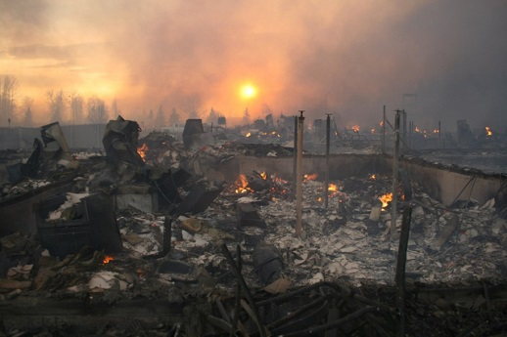

Fire   
The following additional steps are recommended in the event of a fire:

* Cover your nose and mouth with a wet cloth, handkerchief or other suitable item.
* Try to exit the building as quickly as possible.
* Heavy smoke and poisonous gases collect near the ceiling first. If possible, remain below the level of the smoke at all times; this may require you to crawl or move in a crouched position.
* When approaching a closed door, use the back of your hand to feel the lower, middle and upper parts of the door. Never use the palm of your hand or your fingers to test for heat - burning these areas could impair your ability to escape (e.g. using ladders and crawling).
* If the door is not hot, open it slowly and ensure that fire and/or smoke is not blocking your escape route. If your escape route is blocked, shut the door immediately and try to find an alternative route, such as a window. If clear, leave immediately through the door.
* If the door is hot, do not open it. Try to find an alternative route, such as a window. If you cannot escape, hang a white or light-coloured sheet out of the window, alerting firefighters to your presence and location.
* Never go back into the building until a fire official has told you it is safe to do so.

*Trapped under debris*

The following steps are recommended if you are trapped under debris:

* Do not light matches or other incendiary devices.
* Do not move about or kick up dust. Cover your mouth with a cloth, handkerchief or item of clothing.
* Rhythmically tap on a pipe or wall so that potential rescuers can determine your location.
* Use a whistle, if one is available, to alert potential rescuers to your presence.
* Shout only as a last resort, as this can lead to the inhalation of dust and other harmful particles.

## Sexual and Gender Based Violence (SGBV)

As part of orientation, all personnel should be familiar with the CRC policy on sexual harassment and procedures as they relate to the Red Cross Code of Conduct. CRC has also the Safe and Supportive Environments Framework that provides guidance to CRC shelter management with key information, guidance and tools for creating and maintaining ‘safe shelters’ for protection of assisted individuals.

Please consider the following basic facts concerning sexual assault:

* SGBV is an aggressive act motivated by power and control
* Women are most likely victims and most perpetrators are men. However, men and women are vulnerable to SGBV.
* Often, the perpetrator is known to the victim
* SGBV has short and long-term physical, psychosocial and existential effects on health and wellbeing.
* The majority of incidents go unreported.

**In the event that you or someone you know become a victim to SGBV**

* Understand your surroundings and working environment/context.
* Have a plan of action in place.
* Have your emergency contacts accessible.
* PROTECT AND PRESERVE LIFE – attend to physical and psychosocial injuries later. Some responses can escalate violence and harm.

***Options : Immediate Response to Sexual Violence***

There is no single best way to respond when threatened with sexual violence. Survivors should use their best judgment for the specific incident. Consider the following response options while trying to avoid escalating the level of violence.

*Passive resistance:**Verbally try to change the mind of the attacker or ruin the attacker’s desire to have sexual contact.*

*Active resistance****:*** *Use physical force to fight off the attacker* ***ONLY if there is a chance that resisting physically will succeed or that it is the last resort for survival.*** *Scream, shout for help, run away, or fight back.*

*Submit:**If there is no way out and one feels their life is in danger, focus is on survival.*

***Taking the necessary measures to respect and ensure survivor confidentiality, empowerment, autonomy and choices.***

*After an Assault*

Sexual and Gender Based Violence and its aftermath can be a terrifying experience. Survivors often react with a combination of fear and shame and find it difficult to discuss the attack or seek help.

Survivors must remember they are not alone. They deserve sensitive and confidential help. It is the adult survivor’s decision whether or not to report the crime. Though it may be difficult, the attack should be reported to People Services and/or the Protection Team who will then help contact the appropriate authorities. CRC ensures that procedures are in place for the preservation of the survivor’s confidentiality, legal and human rights, and respect of privacy and dignity. Any incident of violence affecting children MUST be reported to CRC Protection Team or appropriate authorities.

## Incidental Exposure to Acts of Violence (collateral damage)

*Shooting incidents*

The risk of being in a situation where you may find yourself under fire from small arms while on foot, in a vehicle, or while in an office is **LOW.** Shooting incidents can take a variety of forms. They could be terrorist-related, linked to a gang dispute or part of an armed robbery. There are also an increasing number of indiscriminate shootings by individuals (or sometimes several people) with personal problems or grudges. The nature of the shooting and the motivation of the shooter(s) will have a direct effect on the level of risk to someone in the area.

If in the vicinity of a shooting incident, the following advice should be considered:

* **If you hear gunfire**, act immediately - move in the opposite direction, putting as much distance as possible between yourself and the shooter. Take cover from fire under hard cover –inside a building with thick walls or multiple walls, ditches (dead ground), behind rock, on the other side of thick and solid walls. If there is nothing close by, drop to the floor and lie flat. **Dash, Down, Crawl, Observe** and stay with your team.Call the emergency services once you are a safe distance away.
* **If in a building:** look for an exit or hide in a room, preferably without windows. Drop instantly to the floor; assess where the firing is coming from; crawl to a place where there are more walls between you and the gunfire, such as in an inner room, corridor, staircase or the middle of a room; stay away from windows, as shattering glass is a major cause of death and injury; lock or barricade the door and stay as quiet as possible. If there is a phone in the room, or you have a mobile phone, call the emergency services as soon as the door is locked or barricaded. If you cannot speak out loud for fear of drawing attention, dial the number and leave the phone off the hook.
* **If leaving the vicinity of the shooting is not possible** and you are in sight of the shooter, stay in a safe area until the firing stops; only move if you really have to; wait for 30 minutes before emerging from cover unless the firing continues and it is still not safe to move.
* Depending on the situation, when the police arrive they may treat everyone as a potential suspect. As such, it is important to follow their instructions.
* Emergency personnel are trained to survey a scene and establish the threat before entering a hazardous area. Don't be shocked if they stay parked outside and do not approach the scene immediately.

**Militant Action**

* If you detect any suspicious behaviour or packages, vacate the immediate vicinity and report to local authorities and your immediate supervisor.
* Exercise vigilance and heightened awareness in areas considered prominent terrorist targets (e.g. government/military buildings, transport hubs, social venues, high profile hotels etc.)
* If an attack occurs while working, ensure you keep abreast of any latest developments through the local medial, and CRC guidance.

*Suspicious packages or letters*

Packages and letters could be used as a container for explosives or chemical or biological agents. Some typical characteristics, which postal inspectors have detected over the years and ought to trigger suspicion, include parcels and letters that:

* Are unexpected or are from someone unfamiliar to you.
* Have no return address, or have one that cannot be verified as legitimate.
* Are marked with restrictive endorsements, such as 'personal', 'confidential' or 'do not x-ray'.
* Have protruding wires or aluminium foil, strange odours or stains.
* Show a city or province in the postmark that doesn't match the return address.
* Are of unusual weight, given their size, or are lopsided or oddly shaped.
* Are marked with any threatening language.
* Have inappropriate or unusual labelling.
* Have excessive postage or excessive packaging material, such as masking tape and string.
* Have misspellings of common words.
* Are addressed to someone no longer with your organization or are otherwise outdated.
* Have incorrect titles or titles without a name.
* Are not addressed to a specific person.
* Have handwritten or poorly typed addresses.

*If on foot in the open when an explosion occurs:*

* Drop instantly to the ground and lie flat.
* If possible, get into a ditch, building or behind a wall.
* Most blast debris and shrapnel flies upwards from the explosion (in a cone shape), so remember to stay as close to the ground as possible.
* Take account of the local situation.
* Leave the area quickly after an explosion.

*If in a vehicle when an explosion occurs:*

* Stop the vehicle, get out quickly and lie flat on the ground away from the vehicle, (e.g., in a ditch if available and deemed safe).
* If you consider that you are the target, then drive away as fast as is safely possible.

*If you are in a building when an explosion occurs:*

* Drop to the floor and move away from windows.
* If it is safe to do so, move into an inner room or a corridor that is better protected than other rooms.
* Stay away from windows.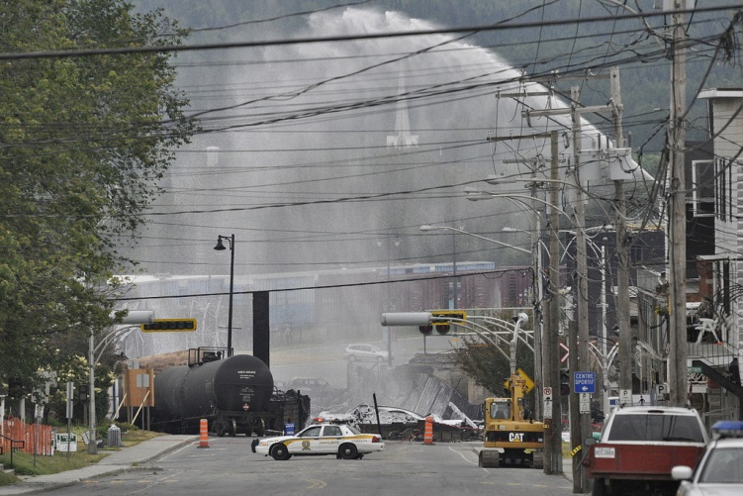

# Other Considerations

## Work Locations/Sites

* Ensure you are familiar with the evacuation procedures and routes, and know the location of nearest fire extinguishers. Locate safety exits and memorize the nearest exit in case of fire or another emergency. Keep a flashlight with you.
* Be alert to people hanging around at key areas inside and outside of the work location. Report anything suspicious.
* Try to work in pairs especially at night and ensure you have communications and key contact numbers with you at all times.

## Information and Advisories

Stay appraised of any changing factors in your working environment (political, social, etc.) as they relate to security. This could include monitoring media and when possible, that relevant information is communicated during briefings and meetings.

## Social Media, Information Management / Information Security

The CRC sometimes gathers, stores and disseminates sensitive or confidential information in the course of undertaking its work in accordance with its humanitarian principles. This includes information regarding security incidents, security procedures, personnel files, staff movement plans, financial records and procedures, and beneficiary lists. Therefore, it is important to always be mindful of the information you collate, how it is stored and communicated to others, and who has access to it. Please consider the following:

**DO:**

* Read and abide by the CRC Information Security guidelines, Information Management and Social Media guidance.
* Keep personnel files, personnel travel movements and contact details **confidential**. Don’t give out colleagues’ addresses or telephone numbers without their permission.
* The use of social media including private accounts of personnel must conform to the rules outlined in CRCS Policies.
* Ensure documents are kept in locked filing cabinets. Sensitive or confidential documents should be stored in an office safe.
* Make sure all financial and personnel records are shredded before discarding. Any discs or data storage devices should also be destroyed before discarding.
* Ensure that sensitive information, files and data stored on the office network / server cannot be accessed without appropriate authorization.
* Use secure passwords / pin numbers on your computer and phone, and change them regularly. Don’t write them down.
* Regularly back up your data and keep it in a secure, separate location.
* Only upload or download information via a secure server.
* Always assume that all your communications could be monitored.
* Make sure there is nothing on your laptop that could compromise you or the CRC if it were stolen, or inspected at customs.
* Most communication systems – radio, landline, mobile phone, and satellite communication – can be monitored, so think before saying or writing anything sensitive.

Social media is easily monitored through the use of accessible and sophisticated tools and technology by all stakeholders with whom we engage. Your social media activity on your private accounts is vulnerable and can be easily identifiable as being from a CRCstaff or volunteer and can impact on the perception of you, your security and that of the CRC and RCRC Movement in general.

* Be careful with group emails. You could unknowingly implicate others, or yourself, to the content of the email or the following replies.

**DO NOT:**

* Record or transmit sensitive information unless there is an urgent need to do so.
* Gather information that might be perceived as contradicting our humanitarian principles of neutrality, impartiality, and independence.
* Share sensitive information, security incidents or CRC security procedures with others or the authorities, without proper authorisation.
* Take photos without permission
* Leave sensitive documents lying on your desk. Always adopt a ‘clear desk’ policy.
* Leave your laptop, phones or documents in an unattended vehicle. Always carry them with you. Lock your computer away, if possible, when leaving the office/work site, or use cable locks to secure it to your desk.
* Send sensitive information via email as it can be easily monitored.

## Stress and Resilience

The nature and environment of our work can often lead to increased stress among staff, volunteers and colleagues. Stress is a normal response to physical and /or emotional demands that allows a person to react promptly and adequately to any given situations. Though, when it lasts too long or exceeds a person’s ability to cope, a person is at risk of becoming exhausted, potentially develop negative coping strategies or stress reactions or can have serious and lasting health effects. As experience has shown, stress among delegates, staff and volunteers, if not monitored and addressed promptly, can become a serious issue in terms of staff health and program effectiveness.

During and post response, CRC provides volunteers and staff and their immediate family members confidential and free access to psychosocial support through its Employee Assistance Provider (EAP). Assistance is available 24/7 through LifeWorks.

Recognizing and Managing Stress

Each delegate and staff is encouraged to complete a “Self-Care Plan” prior their assignment. To help them determine if the timing of an assignment is right or the assignment is the right one for them. A self care plan can help pre-determine potential stress they may encounter on assignment and identify how they plan to manage the stress. Completing this plan or reviewing previous self care plans can help a person identify what items might work well and which will not, providing an opportunity to explore new coping mechanisms or resources. It is also important to return to the Self Care course and review the commons signs and forms of stress Humanitarian workers are at risk for developing.

***Managing stress means knowing yourself (limits, resources and stress reactions), and learning to accept what you cannot change; pace yourself- take one thing at a time.***

Common forms of stress are[[2]](#footnote-2) :

* Basic stress ( day- to day- hassles such as work or family)
* Cumulative stress (prolonged exposure to work and non-work stress)
* Burnout (exhaustion of normal stress coping mechanism)
* Vicarious stress (the cumulative transformative effect on humanitarian workers resulting from helping survivors of traumatic life events[[3]](#footnote-3)); and
* Traumatic or critical incident stress (caused by situations outside the range of everyday experiences and perceived as immediate threats or witnessing events or subject to violence).

**Common Signs and Symptoms of Stress are:**

|  |  |  |  |  |
| --- | --- | --- | --- | --- |
| **PHYSICAL** | **COGNITIVE** | **EMOTIONAL** | **BEHAVIOURAL/**  **RELATIONAL** | **BELIEFS** |
| * Headaches * Disturbed sleep * Nausea * Fatigue * High blood * pressure * Cold sweats, chills * Muscle tremors * Skin problems * Increased heart rate | * Poor decision * making * Nightmares * Indecisiveness * Cynicism * Flashbacks * Lack of concentration * Confusion * Poor memory * Fast / slow reaction | * Mood swings * Guilt * Depression * Resentment * Fear * Anxiety * Anger * Denial * Crying * Irritable * Excitable | * Excessive working * Poor performance * Erratic behaviour * Risk-taking * dangerous driving * Aggressiveness * Angry outbursts * Social withdrawal * Self-neglect * Poor hygiene * Increased alcohol and / or cigarette   use   * Drug abuse * Promiscuity | * Feeling of emptiness * Doubt in religious * Beliefs * Feeling unforgiven * Looking for magical solutions * Loss of purpose of life * Needing to prove self-worth * Cynicism about life |

**Suggestions to manage your stress response and improve your resiliency include:**

*Using you personal resources*

* Talk to someone you trust.
* Being creative with leisure opportunities while on assignment.
* Take time out to play; develop a hobby.
* Use the Employee Assistance Program.
* Contact your Health provider.

*Know yourself (limits, resources and stress reactions, and learn to accept what you cannot change; pace yourself- take one thing at a time.*

* Communicate with your supervisor and others.
* Agree with someone.
* Manage your time better.
* Plan ahead.
* Get enough sleep and rest.

*How to support others experiencing stress*

* Be a good listener.
* Avoid criticizing.
* Be alert to behaviour changes in others around you and propose positive actions if needed (e.g., a break/time off).

*Other things you can do*

* If you become ill or injured- seek medical attention sooner than later
* Think positively, use positive self-talk.
* Set realistic goals
* Eat balanced meals at regular times; limit caffeine and alcohol
* Whenever possible, respect normal working hours- avoid working on weekends.
* Allow for sufficient time for rest, relief and relationships-Don't put off relaxing!

**TO DO:** If you feel you may be experiencing concerning symptoms of stress or have experienced a traumatic event we encourage you to access CRCS’s confidential Employee Assistance Program, and/or other support services at your disposal.

## Handling Cash, Gift Cards and Cash Cards.

The handling of cash, gift cards and cash cards presents many potential security risks. People and vehicles carrying cash or gift cards may be targeted for theft and so are at greater risk of personal harm. Special storage facilities and procedures for handling gift and cash cards are required at each site to maintain control and to ensure that they are not diverted from their original intention.

* Consider lowering the profile of the individuals, times and locations where they are to collect cash or gift cards.
* Limit the amount of cash/gift cards that can be carried by an individual.
* Never disclose in advance that you are collecting cash or gift cards even to anyone in the office not directly involved. If this is a frequent occurrence, vary the route, the timing and the method of travel so as not to create a predictable pattern.
* Use reliable safes that are ideally secured to the floor or wall e.g. bolted or bricked in, in a separate secure room .Keep minimum balances in the safe particularly over weekends and holidays.
* Reduce the use of cash to a minimum, preferring bank transfers or cheques where possible

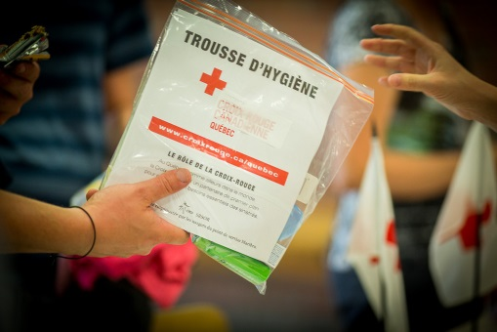

# Incidents and Other Emergencies

**In the event of a situation requiring ANY immediate security or medical assistance, please contact the appropriate local emergency numbers provided for your location**.

Full incident report forms can be obtained from HR and/or Team Leader. All personal information in reports will be kept confidential. Diligence in reporting an incident or near-miss can reduce its consequences. (Quick reaction by the authorities and remedial actions by CRC)

Once immediate actions have been taken and all personnel are safe, report the incident to your immediate supervisor and Human Resources through the most appropriate and expeditious means. This could be done verbally by providing basic details such as: who was involved, what happened, where the incident occurred (be as precise as you can), when did the incident happen, along with what actions were taken by whom and if there is any media interest. *There are other different reporting lines and incident reporting formats/documents for incidents such as breeches to the Code of Conduct; witnessing SGBV within assisted population and Sexual Exploitation and Abuse. Please contact HR and the Protection Team in these situations*. The following types of incidents require the completion of the CRC Incident/Near Miss form for Employees and Volunteers. They include:

* Threats in any format (verbal or written) of harm to people or property.
* Aggression of an individual against CRC volunteer/personnel.
* Thefts of funds, goods, or other assets.
* Transport accidents involving staff resulting in injury or death.
* Personal attack or assault, sexual assault, or attempted assault.
* Shooting , bombing or other explosive incident involving staff.
* Kidnapping or attempted kidnapping, extortion attempts.
* Other incidents as appropriate. (e.g., Fire etc.)

Incident reports are usually of the following kinds:

* Immediate incident report (communicate by mobile phone or in person as soon as possible after the start of the incident, containing only a brief, urgent summary of what has happened).
* Updates (sent as often as necessary, while the incident or the response to the incident continues)
* Full incident report (usually written, sent once the incident has been stabilized or resolved and submitted to immediate supervisor and/or an HR/VR focal point.)

# Checklists

**Domestic Operations – For all who work on CRC responses within Canada** Personnel and visitors mustmaintain awareness and dignity about individual profiles (nationality, ethnicity, religion, sex, gender identity and sexual orientation) and respect other team members’ personal profile.

It is the responsibility of staff and volunteers to be aware of both the security situation in the work location, as well as cultural and socio-economic context.

**In General:**

* Avoid higher risk areas
* Travel in groups especially at night
* Secure important personal items (documents and information)
* Ensure hotels and transport meet basic safety and security standards
* Have ready access to useful emergency contact numbers and keeping in regular contact with colleagues, friends or family
* Familiarize yourself with work site procedures, emergency protocols and other relevant safety and security planning.

***Pre-assignment***

* It is recommended to complete the on-line IFRC Stay Safe Personal Security Training module or IFRC Volunteer Stay Safe.
* Complete the CRC online course on Self Care; and /or review or complete your Self Care Plan.
* Consult with People Service team.
* Inform yourself on safety and security information relevant to your assignment from your immediate supervisor.
* Familiarize yourself with CRC site emergency procedures and plans and CRC’s Health and Safety Policies.
* Receive list of key and emergency contact numbers for location. Carry a hard copy with you of these key contacts (see and complete below).
* Ensure awareness of health risks and take every precaution.
* Ensure that your physical and psychosocial health is appropriate for the assignment.
* Arrange your logistical needs with and through CRC.
* Ensure you, or a team member, have a communication device such as cell phone (and/or VHF radio) for the entire duration of your work and carry your emergency contact list with you at all times.

***During Assignment***

* Obtain a safety and security briefing with CRC before undertaking any activities.
* Understand the need to stay in contact with home and team contacts.
* Know and follow safety and security procedures, emergency protocols, assembly points and contingency plans.
* Ensure you are satisfied with the security standard of your accommodations, work site and transportation.
* Report any safety and security incidents that occur during the visit to your immediate supervisor.
* Comply with CRC policies and procedures etc.
* Determine where the First Aid and AED kits are located.
* Determine where and how to access health care services in the event of an emergency.
* If incident or near miss, obtain an incident report form from People Services, complete and remit as per reporting procedure.

***After Assignment***

* Debrief with immediate supervisor and People Services response team as needed.
* Seek any other medical or psychosocial support via EAP (www. Lifeworks.); other specialised and confidential support and/or peer/line manager support.
* If you were working with a population at risk of communicable diseases, monitor your health for several months.

# Emergency Contacts

Ensure you have access to the most up to date list of CRC Emergency site contact numbers. Carry this list of contacts with you at all times and memorize critical numbers. Please fill out the template below and keep with you at all times.

C:\Users\cpersaud\AppData\Local\Microsoft\Windows\Temporary Internet Files\Content.IE5\78HUMIQN\Scissors-Silhouette-2191-large[1].png

|  |  |
| --- | --- |
| **Function** | **Name and Contact Information/Numbers** |
| **CRC Site Manager/Supervisor** |  |
| **CRC Branch/Office** |  |
| **People Services (HR/VR) contact** |  |
| **Police/Ambulance/Fire** | **911** |
| **Nearest Hospital** |  |
| **Nearest Health Clinic** |  |
| **Insurance emergency contact and policy number** |  |
| **Employee Assistance Number**  **(e.g. LifeWorks)** | 1 855 211 5649 / www.Lifeworks.com  User ID: redcross  Password: lifeworks |
| **Children’s Aid** |  |
| **Other** (Operations Manager/Head of Operations etc.) |  |
|  |  |

# Other Resources

**This booklet is intended as a guidance document and compliments the following:**

|  |  |  |
| --- | --- | --- |
| **Principles, Standards and Policies** |  | **Resources** |
| * The Fundamental Principles of the International Red Cross and Red Crescent Movement * The Canadian Red Cross Code of Conduct * Safe Shelters Framework * Child Protection Policy * The Seven Pillars of Security: acceptance, identification, information, regulations, behavior, communication and protection * Emblem: protective and indicative use * Prevention of Harassment in the Workplace Policy * Prevention of Violence in the Workplace Policy   Guidance on self-care in a response  The Health and Safety Considerations document (must be signed by everyone involved in a response)  Physician’s letter (where and when appropriate)  Link to the Society’s existing insurance for personnel |  | * Security strategies: acceptance, protection, deterrence * Safer Access * Stay Safe: The International Federation’s Guide to a Safer Mission * Staying Alive: Safety and Security Guidelines for Humanitarian Volunteers in Conflict Areas (ICRC) * Other site-specific safety and security guidance, briefings and advisories * Online CRC course: Self-care (CRC) * Other Security training as needed such as CRC Security in Complex Environments (SiCE) |

# Notes

|  |
| --- |
|  |
|  |
|  |
|  |
|  |
|  |
|  |
|  |
|  |
|  |
|  |
|  |
|  |
|  |
|  |
|  |
|  |
|  |
|  |
|  |
|  |
|  |

1. Adapted from RedR UK personal security workbook 2012 [↑](#footnote-ref-1)
2. IFRC (2009), Managing Stress in the field [↑](#footnote-ref-2)
3. Saakvitne & Pearlman (1986) [↑](#footnote-ref-3)